Core
AOP
Services
Data Access
Web
Desktop
Windows Services
3rd Party Integration

- Plain old way
  - ‘new’ your dependencies

- Service Locator
  - use a ‘locator’ to get instances of your dependencies

- Dependency Injection
  - Get your dependencies handed to you.

These all imply certain couplings…

Plain old Dependency creation
- Example:

public class Foo {

private IBar bar;
private IBaz baz;

public Foo() {
bar = new SomeBar();
baz = new SomeBaz();
}
}

Characteristics
- Cons
  - Your class depends upon all it’s dependencies depend on.
  - Your class must know how to assemble instances of it’s dependencies and their dependencies.
  - Hard to change behavior without opening code
  - Hard to test as you must also test depends. Cannot use mocks.
- Pros
  - Easy to understand
Service Locator
- Example:

public class Foo {

private IBar bar;
private IBaz baz;
private IServiceLocator locator;

public Foo(IServiceLocator locator_) {
locator = locator_;
bar = locator.Get(
ServiceNames.BAR
);
baz = new SomeBaz(
ServicesNames.BAZ
);
}
}

Characteristics

- Cons
  - Your class depends upon the service locator
  - You must still get the locator to the class – either statically (yuk) or via… some sort of injection like mechanism

- Pros
  - Easy to understand
  - Testable
  - Flexible
  - Extensible
  - Enforces separation of interface from implementation
Inversion of Control
- Example:

public class Foo {
private IBar bar;
private IBaz baz;
public Foo(IBar bar_, IBaz baz_) {
bar = bar_; baz = baz_;
}
}
Characteristics

- Cons
  - You must create dependencies to pass along

- Pros
  - Easy to understand
  - Testable
  - Flexible
  - Extensible
  - Enforces separation of interface from implementation
  - Code is simple and clear
- Inversion Of Control, Dependency Injection, The Hollywood Principal etc.

In stead of instantiating concrete class references in your class, depend on an abstraction and allow your concrete dependencies to be given to you.

Injection Types
- Setter Injection
  - Pass dependencies in via mutators/ property setters

- Constructor Injection
  - Pass dependencies in via constructor

WithOut IOC
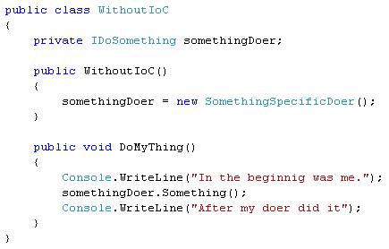

Concrete Class Dependency
Allow dependency to be passed in
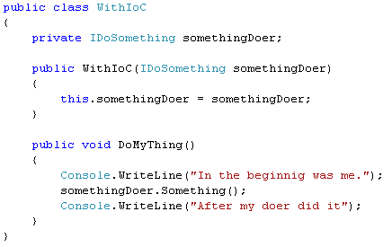

Same thing – with property setter
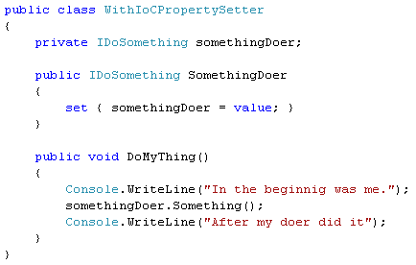
The problem with IoC by itself
- To build these objects now takes assembling the whole object graph of dependencies!!! What a pain!!!
Containers to the rescue
- The solution is a container – to manage the complex creation, lifecycle, etc.

- This is where Spring comes in.
  - To manage complex object assembly
    - I ask for object named “Y” – the container gets any dependencies for that type, creates then or gets cached instances – gives them to the object I am trying to get and returns me that object. I then use this object as I normally would.

  - To manage object lifecycles
    - Singleton-ness or Non-Singleton-ness
At it’s core – Spring is a framework for wiring up your entire application.
- Object Factory
  - The thing that creates object instances for you
  - You ask the object factory for a named item – it returns an instance to you – either a singleton or a prototype.

- Singleton
  - There is 1 and only 1 instance
  - Each time you ask the object factory for one – you get the same one

- Prototype
  - This is a ‘non-singleton’
  - Each time you ask the object factory for one – you get a new one
Object factory as a Service Locator
- Ideally – you could use Spring to ask for an object at the ‘top level’ of your application – and it would give you back an entire object graph of fully baked objects. That said – this is not always feasable.

- You can use Spring as a service locator – or as an implementation detail of your service locator. Service locator is a great alternative to IoC – especially when things like ‘UI designers’ ‘New’ your objects in for you. Depending on how you do this – you could be more or less tied to spring (that is not great). In the past – I have tried to make spring an implementation detail – and hide it behind my own abstraction for locator.
Why IoC with a Container
- Support programming best practices:
  - Separation of interface from implementation
    - Allows you to substitute implementation

  - Code is smaller and cleaner – program your intent – not how to create your dependencies and their dependencies etc.

  - The Dependency Inversion Principle (DIP)
    - Depend upon Abstractions. Do not depend upon concretions.

  - The Open Closed Principle (OCP)
    - A module should be open for extension but closed for modification. Of all the principles of object oriented design, this is the most important. It originated from the work of Bertrand Meyer . It means simply this: We should write our mod-ules so that they can be extended, without requiring them to be modified. In other words, we want to be able to change what the modules do, without changing the source code of the modules.
Why IoC - continued
- Testability
  - You can substitute implementation – specifically pass in a Mock object so you only write code to test the code you are writing. You are NOT testing the code in your dependencies.

- Manages assembly of complex objects for you!

- Reduce coupling of code

- Easy reconfiguration

- Reusability increase due to decoupling
Other IoC Related Frameworks
- Hivemind
- Pico Container
- Copeland
- StructureMap
- EJB 3
- JBoss Seam
- Object Builder in Microsoft CAB
